

**: Web App Development :**

**Lab-1,2**

Khansa Noor-54039

**Submitted to:** Ma’am Nayab Khalid

Lab-1

<!DOCTYPE html>

<html lang="en">

<head>

    <meta charset="UTF-8">

    <meta name="viewport" content="width=device-width, initial-scale=1.0">

    <title>Login Page</title>

</head>

<body>

    <body style="background-color: rgb(190, 209, 238);align-items: center; justify-content: center;display: flex;justify-content: center">

        <div style="background: rgb(116, 160, 217); padding: 20px; border-radius: 8px; box-shadow: 0 0 10px rgba(0, 0, 0, 0.1); text-align: center">

           <h3 style="background-color: aliceblue;">  Login Form </h3>

    <div class="main">

        <form>

        <body style="background-color: grey;"></body>

        <label>Email:</label>

        <input type="text" placeholder="e-mail" required style="gap: 2px;">

        <br>

        <br>

        <label>Password:</label>

        <input type="password" placeholder="Enter your password" required >

        <br>

        <br>

        <input type="checkbox">

        <label>remember</label>

        <br>

        <br>

        <input type="submit"  style="width: 100%; padding: 10px; background: #007BFF; color: white; border: none; border-radius: 5px; cursor: pointer;">

    </form>

    </div>

</body>

</html>

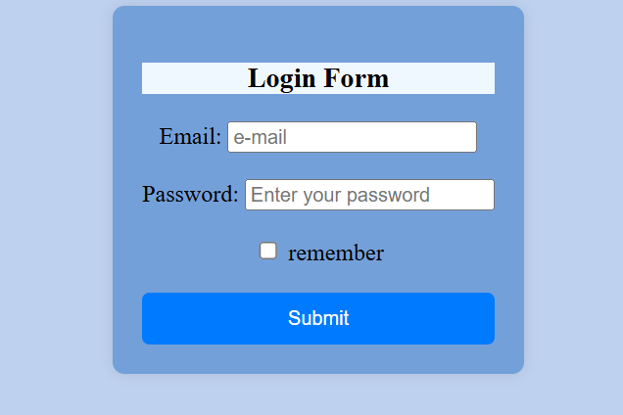

**Lab-2 (task-1)**

<!DOCTYPE html>

<html lang="en">

<head>

    <meta charset="UTF-8">

    <meta name="viewport" content="width=device-width, initial-scale=1.0">

    <title>Login Page</title>

</head>

<body style="background-color: rgb(233, 237, 244);align-items: center; justify-content: center;display: flex;justify-content: center">

 <div style="background: rgb(62, 89, 125); padding: 20px; border-radius: 8px; box-shadow: 0 0 10px rgba(0, 0, 0, 0.1); text-align: center">

    <h3 style="background-color: aliceblue;">  Login Form </h3>

    <label>First Name:</label>

    <br>

    <input type="text" placeholder=" Enter your first-name" required >

     <br>

    <label>Last Name</label>

    <br>

    <input type="text" placeholder="Enter your last-name">

    <br>

    <label>City:</label>

    <br>

    <input type="text" placeholder="Enter your city"  readonly required>

    <br>

    <label>Zip-code:</label>

    <br>

    <input type="text" placeholder=" zip_code" maxlength="4" required>

    <br>

    <label>Date of birth:</label>

    <br>

    <input type="date" placeholder="date">

    <br>

    <br>

    <input type="submit"  style="width: 100%; padding: 10px; background: #007BFF; color: white; border: none; border-radius: 5px; cursor: pointer;">

</div>

</body>

</html>

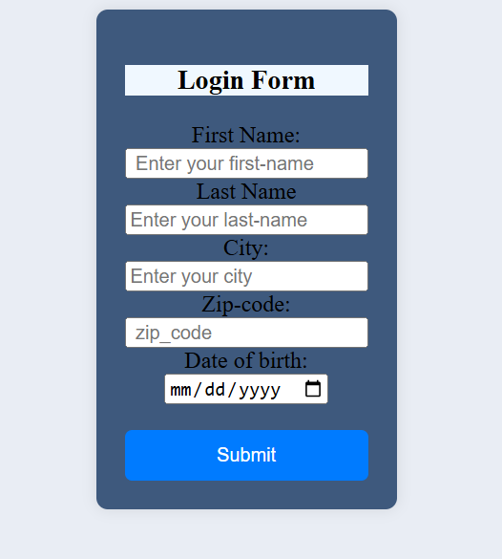

**Lab-2 (task-2)**

<!DOCTYPE html>

<html lang="en">

<head>

    <meta charset="UTF-8">

    <meta name="viewport" content="width=device-width, initial-scale=1.0">

    <title>Document</title>

</head>

<body>

    <body style="background-color: rgb(179, 217, 222);"></body>

    <h2 style=" text-align: center"> Students Academic record </h2>

    <div style="background: white; padding: 20px; border-radius: 8px; box-shadow: 0 0 10px rgba(0, 0, 0, 0.1); text-align: center;">

    <table  style="width: 100%; border: 2px solid black;">

         <tr>

            <th style="background-color: aquamarine; border: 2px solid black;">NAME</th>

            <th style="background-color: aquamarine; border: 2px solid black;">GRADE</th>

            <th style="background-color: aquamarine; border: 2px solid black;">SUBJECT</th>

         </tr>

         <tr>

            <td style="padding: 10px; border: 2px solid black;">Khansa Noor</td>

            <td style="padding: 10px; border: 2px solid black;">A+</td>

            <td style="padding: 10px; border: 2px solid black;">Web App Development</td>

         </tr>

         <tr>

            <td style="padding: 10px; border: 2px solid black;">Fasiha Tariq</td>

            <td style="padding: 10px; border: 2px solid black;">A+</td>

            <td style="padding: 10px; border: 2px solid black;">Web App Development</td>

         </tr>

         <tr>

            <td style="padding: 10px; border: 2px solid black;">Urba Naseem</td>

            <td style="padding: 10px; border: 2px solid black;">A+</td>

            <td style="padding: 10px; border: 2px solid black;">Web App Development</td>

         </tr>

         <tr>

            <td style="padding: 10px; border: 2px solid black;">Shiza Shahid</td>

            <td style="padding: 10px; border: 2px solid black;">A+</td>

            <td style="padding: 10px; border: 2px solid black;">Web App Development</td>

         </tr>

         <tr>

            <td style="padding: 10px; border: 2px solid black;">Ayesha Fatima</td>

            <td style="padding: 10px; border: 2px solid black;">A+</td>

            <td style="padding: 10px; border: 2px solid black;">Web App Development</td>

         </tr>

        </div>

    </table>

</body>

</html>

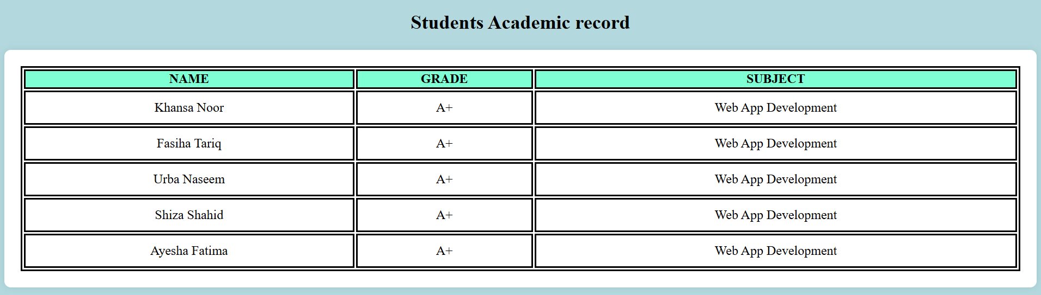

**Lab-2 (task-3)**

<!DOCTYPE html>

<html lang="en">

<head>

    <meta charset="UTF-8">

    <meta name="viewport" content="width=device-width, initial-scale=1.0">

    <title>Registration Page</title>

</head>

<body style="background-color: rgb(147, 187, 130) ;align-items: center; justify-content: center;display: flex;justify-content: center"></body>

<div style="background: white; padding: 20px; border-radius: 8px; box-shadow: 0 0 10px rgba(0, 0, 0, 0.1);">

    <h1> Registration form </h1>

    <p>Please fill in this form to register.</p>

    <p>-------------------------------------------------------------------------------------------------------</p>

    <div style="display: flex; justify-content: center; align-items: center; gap: 16px;">

    <label>First Name:</label>

    <input type="text" placeholder="first-name" required >

    <label>Last Name</label>

    <input type="text" placeholder=" last-name">

    </div>

    <br>

    <br>

    <div style="display: flex; justify-content: center; align-items: center; gap: 29px;">

    <label>Email:</label>

    <input type="text" placeholder=" email"  required >

    <label>Password:</label>

    <input type="password" placeholder=" password" maxlength="8" required>

    </div>

    <br>

    <br>

    <div style="display: flex; justify-content: center; align-items: center; gap: 30px;">

    <label>Gender:</label>

    <br>

    <input type="radio" placeholder="Male">

    <label>Male</label>

    <input type="radio" placeholder="Female">

    <label>Female</label>

    <input type="radio" placeholder="Other">

    <label>Other</label>

</div>

    <br>

    <br>

    <div style="display: flex; justify-content: center; align-items: center; gap: 45px;">

    <label>Age:</label>

    <input type="number" placeholder="Age">

    <label>Date of birth:</label>

    <input type="date" placeholder="date">

</div>

    <br>

    <br>

    <div style="display: flex; justify-content: center; align-items: center; gap: 25px;" >

    <label>Address:</label>

    <input type="text" placeholder="Your Address" required >

    <label>Contact No:</label>

    <input type="number" placeholder="contact number">

</div>

    <br>

    <br>

    <input type="submit"  style="width: 100%; padding: 10px; background: #05663f; color: white; border: none; border-radius: 5px; cursor: pointer;">

    <br>

    <br>

    <a href="file:///C:/Users/Saad%20Abdur%20Rehman/OneDrive/Documents/WAD%20LAB/login%20form.html"> log-in page</a>

</div>

</body>

</html>

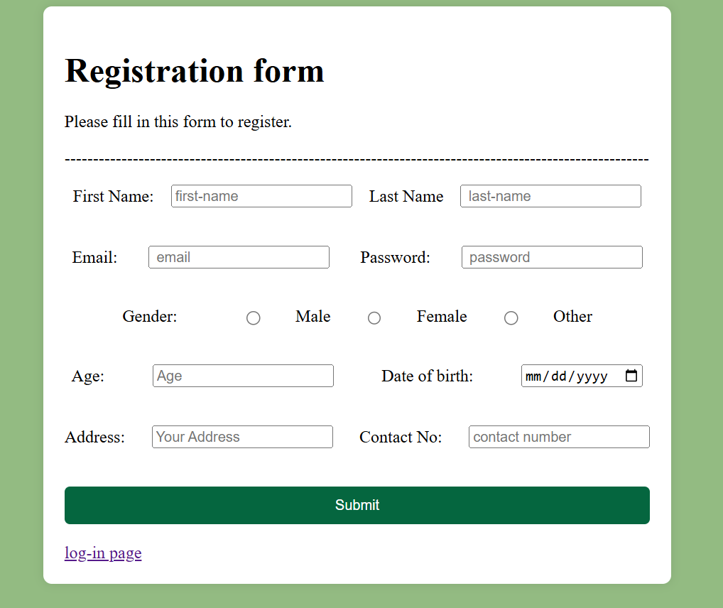

**Lab-2 (task-4)**

<!DOCTYPE html>

<html lang="en">

<head>

    <meta charset="UTF-8">

    <meta name="viewport" content="width=device-width, initial-scale=1.0">

    <title>Document</title>

</head>

<body>

    <body style="background-color: rgb(215, 150, 202);"></body>

    <h1><i>SEASONS...</i></h1>

    <label> <b> <i> <u>SPRING SEASON:</u> </i> </b> </label>

       <p> Spring is a beautiful and refreshing season that marks the transition from winter to summer. It is known for blooming flowers, pleasant weather, and longer days. Trees regain their green leaves, and colorful blossoms create a vibrant atmosphere. Birds return from migration, filling the air with cheerful songs. The temperature is mild, making it a perfect time for outdoor activities like picnics and gardening. Spring also symbolizes renewal and growth, as nature awakens from the cold winter months. Many cultures celebrate festivals during this season, welcoming the warmth and beauty that spring brings.</p>

       <p>Spring is a season of renewal, bringing life and color back to nature. The days become warmer, and flowers like tulips, daisies, and cherry blossoms bloom, creating breathtaking landscapes. Fresh green leaves cover the trees, and the air is filled with the sweet scent of blossoms. Animals come out of hibernation, and birds chirp joyfully, signaling the arrival of a new season. Spring is also a time of inspiration, encouraging people to enjoy nature, take peaceful walks, and embrace positivity. With its refreshing breeze and lively atmosphere, spring fills the world with beauty, hope, and happiness.</p>

    <label> <b> <i> <u>SPRING SEASON:</u> </i> </b> </label>

       <p> Summer is the warmest season of the year, known for its bright sunshine, long days, and high temperatures. It is a time when people enjoy vacations, outdoor activities, and refreshing treats like ice cream and cold drinks. Many head to beaches, swimming pools, or hill stations to escape the heat. Plants grow rapidly due to ample sunlight, and fruits like mangoes, watermelons, and berries are in abundance. Although summer can be hot and sometimes exhausting, it is also a season of fun, adventure, and relaxation. It brings joy through festivals, family trips, and the beauty of nature in full bloom.</p>

       <p> Summer is a season full of energy, brightness, and excitement. Schools close for vacations, giving children time to play, travel, and explore new hobbies. People enjoy outdoor activities like swimming, hiking, and barbecues with family and friends. The days are longer, allowing more time for fun and adventure. While the heat can be intense, cool drinks, fresh fruits, and evening breezes bring relief. Summer also brings festivals and celebrations that add to the joy of the season. Despite the scorching sun, the warmth and vibrancy of summer make it one of the most enjoyable times of the year.</p>

</body>

</html>

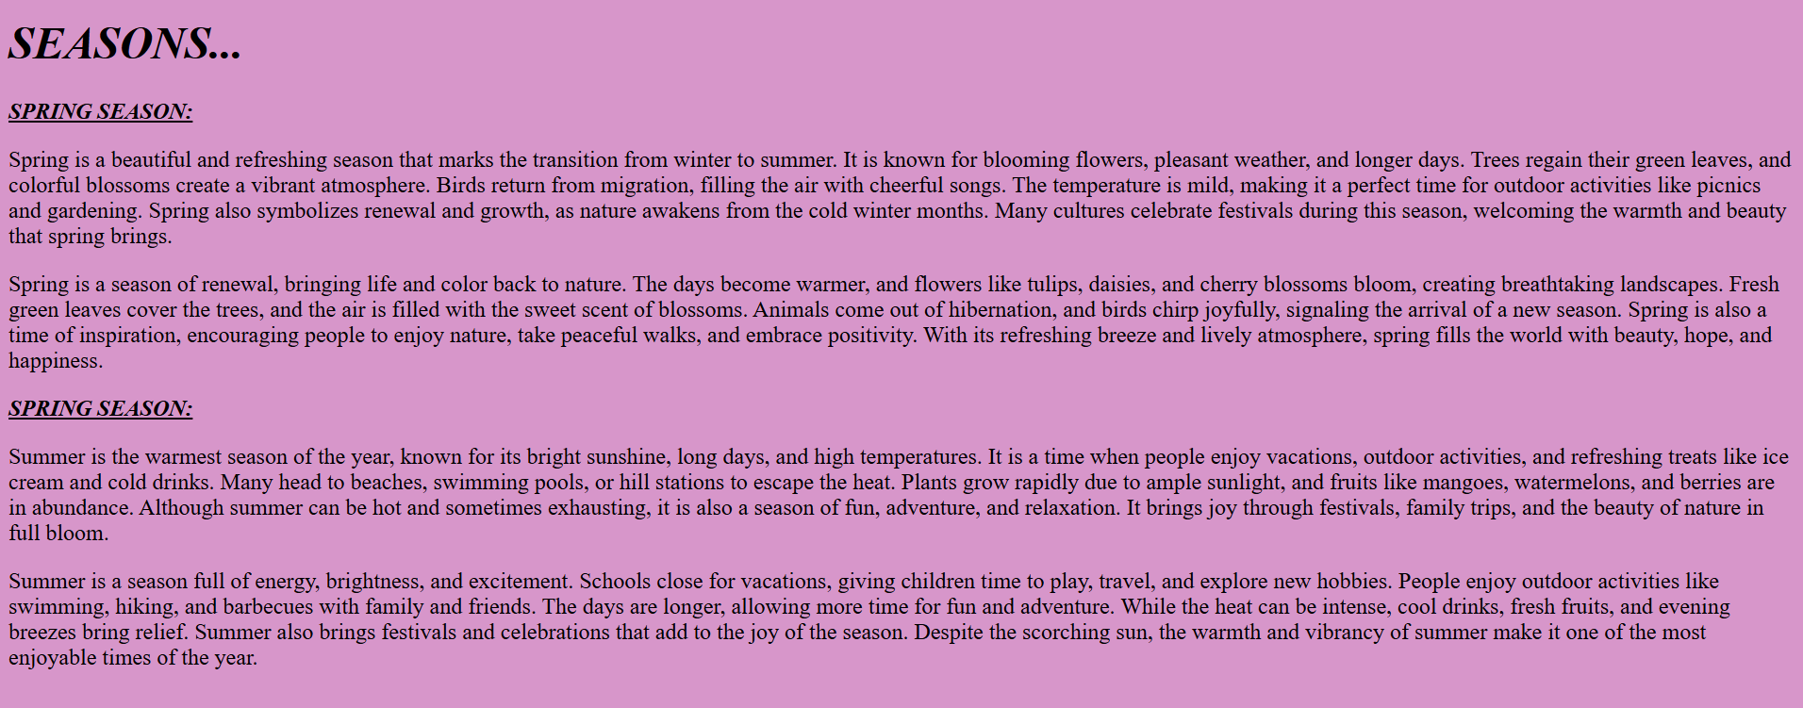

**>> End <<**